# Task P3.1.4

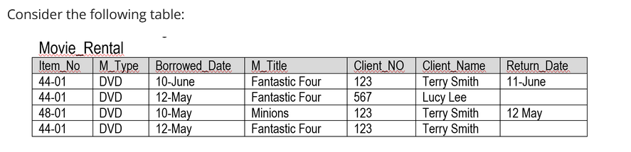

1. Which **string data type** is best to be used in the declaration of the column “Title”? Explain why?

* VARCHAR(n)

Because, Title doesn’t have fixed length so varchar would be perfect fit for this column

1. Choose a **primary key** for this table.

* Combination of **Borrowed_Date + Client_NO** would be best for primary key because combination of both is unique for each row(however, there is hyphen in name but I consider this because I take that this as DATE type instead of VARCHAR or CHAR data type.)